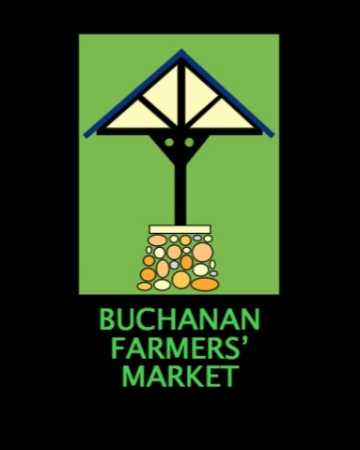
VENDOR APPLICATION

574-213-4774
The market will be a drop-off point for food donations for Red Bud Area Ministries (RAM) and Little Pantries again this year.

PRINT CLEARLY
Name ________________________________________________________________________
Mailing Address ________________________________________________________________
________________________________________________________________
Contact Phone Number __________________________________________________________
Email Address __________________________________________________________________
Business’ Name _________________________________________________________________
Products to sell _________________________________________________________________
Preference: _____ Permanent Booth _____ Own Setup
Payment: ___Permanent Booth $300 full season if paid in full by April 25
___ $15 per week if permanent booth space is available (choose dates below)
___Tent Space $240 full season if paid in full by April 25
___Tent Space $15 per week (choose your dates below)
DATES FOR 2026
May 2 June 6 July 4
9 13 11
16 20 18
23 27 25
30

August 1 September 5 October 3
8 12 10
15 19
22 26
29

